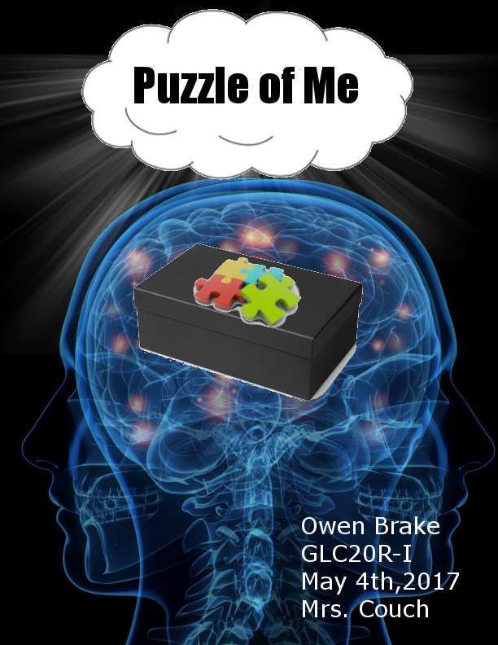

Puzzle of Me

I built a puzzle of me box to represent myself for this project and put objects which are symbolic of my past, present and future. I used a baseball championship ring and my arcade machine to represent my past, an Arduino board to represent my present, the novel 1984 to represent my future and my Vex World championship medal to represent my choice to be in the SciTech program. These objects best represent me and my goals for the future.

I used my baseball championship ring since it is symbolic of my past. Ever since I was in elementary school I have loved the sport of baseball, I have spent many years playing baseball and in recent years I have umpired games in the summer. In grade 7 my team won the playoff championships for the league and it was an amazing experience for me, we were given a championship ring for winning in the playoffs. The sport has taught me many things, as a young student it was important to learn about the importance of teamwork and excellence. Since the sport of baseball has been so important to me when I was young that is why I put the ring in my box.

My second choice to represent my past was my arcade machine. The arcade machine is built out of wood and the electronic use a small computer known as a raspberry pi, joysticks and buttons so as to have a realistic feel. In late grade 8 me and my dad built an arcade machine, I setup all the wiring and cut wood and he bought all of the parts. This was a great project because it tested my mechanical and electronic skills, it is one of the reasons I got into SciTech is because a big portion of my application was my arcade machine since it mixed my two interests computer science and manufacturing. The project also taught me many things including the mixture between handling with real world input such as buttons and joysticks with software which was new to me. That is why I chose to put the arcade machine in my puzzle of me box because it taught me so many things and is symbolic of my interests and hobbies.

I chose to use an Arduino board to represent my present. I chose the Arduino board because I feel it represents my interest in technology and computer science. I like and use this board because it creates a good blend of hardware electronics and the software side of programming so it challenges the creator in multiple ways. Throughout high school I have used this board for academic and personal projects and it has greatly improved my knowledge in electronics and programming. This object has taught me so many things, it has helped me on many school projects and it is symbolic of my hobbies and aspirations that is why I chose this object to represent my present.

I selected my vex robotics medal to represent my choice to be in the SciTech program. In September of 2016 I joined the vex robotics club where I worked as a builder and a programmer. After provincials in February the club qualified for worlds and I was able to go to the world championship and we did quite well, almost making it to the finals. The trip was fantastic and taught me so many things about designing, build quality and programming which is very important for my career goals and for next year when the grade 12s are gone. I chose this object because it represents my SciTech experience in this school and it was a great experience which I will never forget.

I chose to put the novel 1984 in my puzzle of me box because it has been highly influential in my life and it will continue to be for my future. I chose this because the novel 1984 shaped my political views and changed how I perceive the world, since hobbies or dreams will change with time and one may grow out of them the one thing that will not change is people’s ideas and sincere beliefs. The novel 1984 explores the problems with totalitarianism and the problems with capitalism, the book explains how the workers which the book even calls the proletariat are the oppressed people in society. This also would represent my future because I plan to be active in politics and the novel 1984 has helped make me more interested in politics. Overall the novel 1984 has shaped my political opinions and made me interested in politics which is one of the most important things that dictate our lives.

My puzzle of me box is used to represent everything about me. The box included a baseball championship ring and my arcade machine for my past, an Arduino board to represent my present, the novel to represent my future and finally a robotics medal to represent my participation in SciTech. All of these objects are symbolic of me in some way, they are symbolic of my goals, my past and my personality.